
Tertiary Infotech Academy Pte Ltd
UEN: 201200696W
LEARNER GUIDE
For
Innovating Product Development with 3D Printing and Additive Manufacturing
TGS Ref No: TGS-2022017597
Conducted by
Tertiary Infotech Academy Pte Ltd
UEN: 201200696W
Version 8.1

DOCUMENT VERSION CONTROL RECORD
Version Number | Effective Date of Release | Summary of Included Changes | Author
7.0 | 1 June 2025 | Legacy release accompanying the v7 trainer deck. | Dr Alfred Ang
8.0 | 18 August 2026 | Full regeneration: 16 hands-on labs with detailed step-by-step guides (Fusion 360 design labs, Cura slicing/adhesion/support labs, optimisation and post-processing labs), enriched AM theory, revision section mapped to K1–K7 / A1–A5, and expanded glossary. | Dr Alfred Ang
8.1 | 22 August 2026 | Enhanced Labs 5 and 7–16 with supplied editable, STL and Cura diagnostic assets; added model-specific procedures, evidence requirements and acceptance checks; aligned the deck, Learner Guide and labs. | Dr Alfred Ang

TABLE OF CONTENTS
Introduction 4
Course Learning Outcomes 4
Before You Start — Environment Setup 5
Topic 01 — Overview of Additive Manufacturing and 3D Scanning 5
Lab 1 — Extrude — Personalised Keychain Token 6
Lab 2 — Sweep — Giant Paper Clip Bookmark 8
Lab 3 — Loft — Mini Plant Pot with Custom Rails 11
Lab 4 — Revolve — Funnel from a 2D Profile 13
Lab 5 — Tolerance — Container and Lid (0.2 mm Fit) 15
Lab 6 — 3D Scan and Print a Real Object 18
Topic 02 — Process Related Issues for AM 20
Lab 7 — Install Cura and Slice Your First Model 21
Lab 8 — Bed Adhesion — Skirt vs Brim vs Raft 23
Lab 9 — Support Structures for Overhangs 25
Lab 10 — Filament Diagnostics — Diameter, Temperature and Flow 28
Topic 03 — Process Improvement for AM 30
Lab 11 — Perimeters and Infill — Strength vs Speed 31
Lab 12 — Infill Patterns — Zigzag vs Grid Strength Test 33
Lab 13 — Layer Height and Top Thickness — Surface Quality 35
Lab 14 — Ironing — Glass-Smooth Top Surfaces 37
Lab 15 — Fuzzy Skin — Textured Walls on a Vase 39
Lab 16 — Post-Processing — Support Removal and Sanding 42
Revision — What to Master for the Assessment 45
Glossary 46

Introduction
This Learner Guide accompanies the WSQ course Innovating Product Development with 3D Printing and Additive Manufacturing (TGS-2022017597), conducted by Tertiary Infotech Academy Pte Ltd. It provides step-by-step instructions for all 16 hands-on labs, organised by the three course topics, and supports the TSC Additive Manufacturing (PRE-OPR-4012-1.1).
Use this guide alongside the course slides and the per-lab folders in labs/ of the course repository. Each lab folder carries this guide's steps plus any sample model files (STL) the lab needs. The written and practical assessments are open book — bring this guide.

Course Learning Outcomes
- LO1: Analyze the AM and evaluate the use of reverse engineering using 3D scanning
- LO2: Analyze the issues and determine the requirements for AM processes
- LO3: Apply AM optimization techniques and assess the impact of process improvement
TSC coverage
- A1: Analyse and determine material considerations of components to be manufactured
- A2: Analyse process-related issues for using DMLS, SLS, SLM, powder bed and inkjet head, and/or 3D printing for AM
- A3: Determine processes and procedures for manufacturing metallic and non-metallic components using AM
- A4: Evaluate use of reverse engineering processes for components through 3D scanning and subsequent AM
- A5: Apply optimisation techniques to improve efficiency of AM processes and product quality
- A6: Assess the impact of manufacturing process improvements on business operations
- K1: AM characteristics, techniques and systems
- K2: Requirements of different AM processes
- K3: Factors to be considered when selecting AM solutions
- K4: Impact of AM on manufacturing operations
- K5: Methods for reviewing AM performance
- K6: Benefits and trade-offs of AM
- K7: Methods of ensuring long-term sustainability of AM

Before You Start — Environment Setup
What you need
- A computer with Autodesk Fusion 360 installed — the free personal-use or education licence is sufficient (https://www.autodesk.com/products/fusion-360).
- Ultimaker Cura slicing software — free from https://ultimaker.com/software/ultimaker-cura (installed in Lab 7; install early if you want a head start).
- An FDM 3D printer with PLA filament (provided in class), plus digital calipers, pliers and sandpaper (120–400 grit) for the tolerance and post-processing labs.
- A smartphone with a 3D-scanning app for Lab 6 — Polycam or Kiri Engine (Android/iOS), or Scandy Pro / Heges on LiDAR iPhones/iPads.
- The sample and diagnostic models in each labs/ folder, including calibration cubes, support/orientation benchmarks, retraction and cooling tests, wall-line tests, optimisation variants and finishing parts.
Fusion 360 quick orientation
- Sketch-driven CAD: draw 2D profiles on sketch planes, then turn them 3D with Extrude, Revolve, Sweep and Loft.
- The browser (left panel) lists bodies, sketches and construction planes; the timeline (bottom) records every operation for editing.
- Export any body for printing via File ▸ Export ▸ STL, or right-click the body ▸ Save As Mesh.
Conventions used in every lab
- Menu paths are written as Tool ▸ Menu ▸ Command (e.g. Create ▸ Extrude).
- Values shown (dimensions, temperatures, percentages) are tested starting points — your printer may need small adjustments.
- Every lab ends with a 'Test it' check — do not move on until it passes.
- Safety: hot nozzles (200 °C+), moving axes and sharp tools — keep hands clear while printing and use pliers for support removal.

Topic 01 — Overview of Additive Manufacturing and 3D Scanning
AM systems · material considerations · benefits & trade-offs · 3D scanning and reverse engineering (K1, K3, K6 · A1, A4)
Key concepts
- Additive manufacturing — Builds parts layer by layer directly from a CAD file — no part-specific tools, dies or molds.
- Seven process families — Material extrusion, vat photopolymerisation, powder bed fusion, material jetting, binder jetting, directed energy deposition, sheet lamination.
- Material considerations — Mechanical/thermal properties, design complexity, volume, post-processing and cost drive the choice of AM solution.
- Benefits & trade-offs — Design freedom, rapid prototyping and low-waste versus slower throughput, material limits and post-processing.
- 3D scanning — Captures real-world geometry so worn or legacy parts can be reverse-engineered into CAD and re-manufactured with AM.
- Design for AM — Fusion 360 extrude, sweep, loft and revolve; stress concentration and tolerance-aware design.

Lab 1 — Extrude — Personalised Keychain Token
TSC objective: A1 — determine material and design considerations while modelling a printable part with the extrude technique.
Goal: Model an elliptical keychain token in Fusion 360, personalise it with the first letter of your name, then slice it in Cura and 3D print it.
What you'll build
A personalised elliptical keychain token, sliced and 3D printed in PLA. (Tools: Fusion 360, Ultimaker Cura, FDM printer (PLA).)
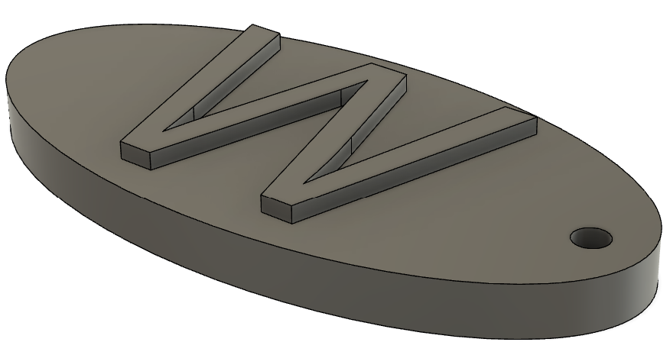
Lab 1 reference — target model / setting
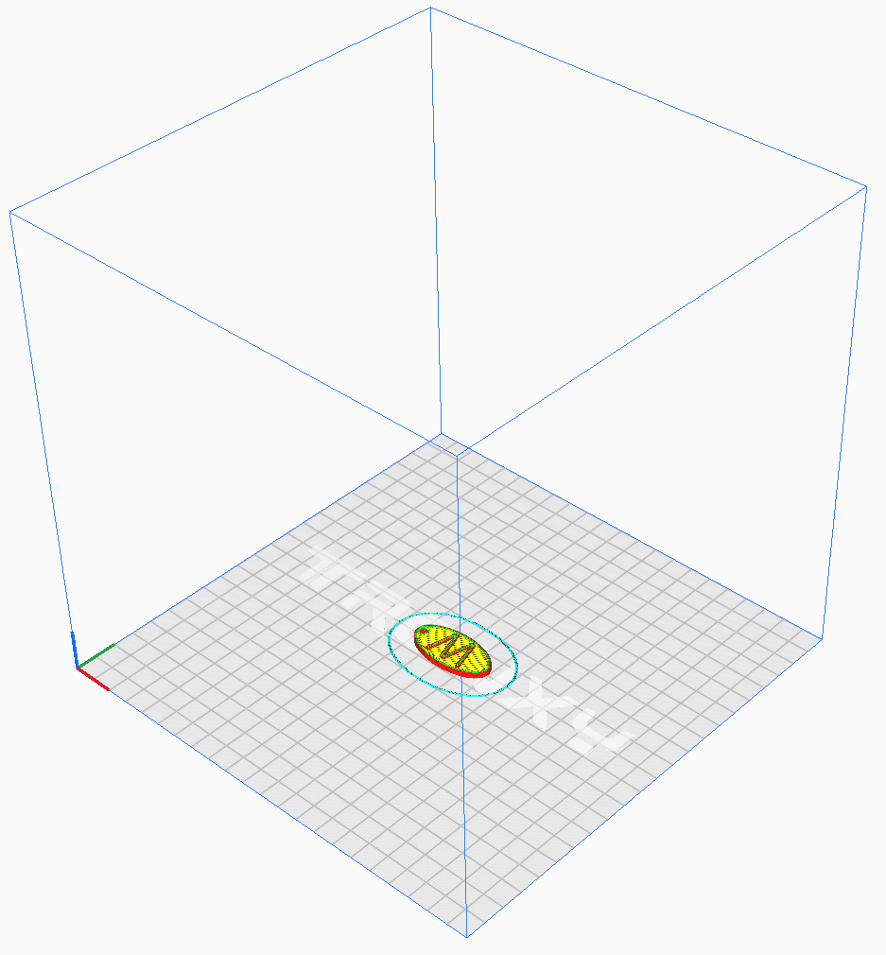
Lab 1 reference — as prepared in the tool
Step-by-step
- Create a new design in Fusion 360 and start a sketch on the XY plane.
Fusion 360 ▸ File ▸ New Design ▸ Create Sketch ▸ XY plane
- Draw an ellipse about the origin — approximately 50 mm long and 30 mm wide.
Sketch ▸ Ellipse — major 50 mm, minor 30 mm
- Add a 4 mm circle near one end of the ellipse for the keyring hole, then finish the sketch.
Sketch ▸ Circle — Ø 4 mm ▸ Finish Sketch
- Extrude the ellipse profile (excluding the circle) to 3 mm to form the token body.
Create ▸ Extrude — profile: ellipse, distance 3 mm
- Sketch the first letter of your name on the token's top face and extrude it 1 mm.
Create Sketch ▸ Text — height 18 mm ▸ Extrude 1 mm (Join)
- Export the body as an STL mesh for slicing.
File ▸ Export ▸ STL (or Utilities ▸ Make ▸ 3D Print)
- Open the STL in Cura, keep the flat face on the build plate, and slice with the default 0.2 mm profile.
Cura ▸ Open File ▸ token.stl ▸ Slice
- Save the G-code and print the token; remove it from the bed once cooled.
Cura ▸ Save to Disk ▸ print
Evidence to capture
- Fusion 360 screenshot showing the ellipse, 4 mm keyring hole and raised initial.
- Cura Preview screenshot confirming flat orientation and no supports.
- Photo or inspection note confirming the printed initial and clear keyring hole.
Test it
The sliced preview shows the token printing flat with no supports; the printed token carries your raised letter and the keyring hole is clear.
Note: This lab lives in labs/lab-01-extrude-personalised-keychain-token/ together with any sample files it needs.

Lab 2 — Sweep — Giant Paper Clip Bookmark
TSC objective: A1 — apply the sweep technique to produce a printable path-driven part.
Goal: Model a giant paper clip bookmark in Fusion 360 by sweeping a circular profile along a paper-clip path, then slice and 3D print it.
What you'll build
A giant paper clip bookmark modelled with the sweep technique and 3D printed flat. (Tools: Fusion 360, Ultimaker Cura, FDM printer (PLA).)
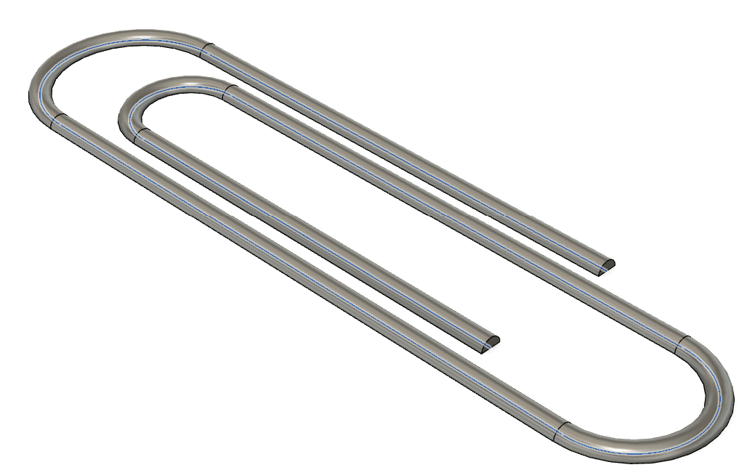
Lab 2 reference — target model / setting
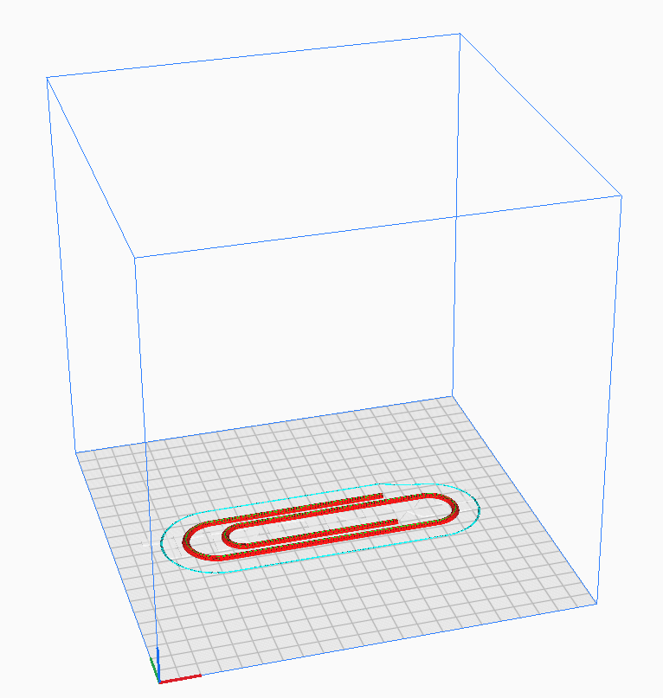
Lab 2 reference — as prepared in the tool
Step-by-step
- Start a sketch on the XY plane and draw the paper-clip path — three nested U-turns — using the Line and Arc tools.
Create Sketch ▸ Line + Arc (3-point) — overall ~90 × 35 mm
- Add fillets so every corner of the path is a smooth arc, then finish the sketch.
Sketch ▸ Fillet — radius 5 mm ▸ Finish Sketch
- Create a plane perpendicular to one end of the path and sketch a 2.5 mm circle on it.
Construct ▸ Plane Along Path (t=0) ▸ Sketch ▸ Circle Ø 2.5 mm
- Sweep the circle along the path to form the solid clip.
Create ▸ Sweep — profile: circle, path: clip sketch
- Export the body as an STL file.
File ▸ Export ▸ STL
- Open it in Cura and lay the clip flat on the build plate so no supports are needed.
Cura ▸ Open File ▸ clip.stl ▸ Rotate — flat
- Slice with a 0.2 mm profile and print.
Cura ▸ Slice ▸ Save to Disk ▸ print
Evidence to capture
- Fusion 360 screenshot showing the path, perpendicular profile and completed sweep.
- Cura Preview screenshot confirming full build-plate contact and no supports.
- Photo or inspection note showing that the printed clip flexes and grips pages.
Test it
The preview shows the whole clip printing in contact with the bed; the printed clip flexes slightly and grips a few pages like a real paper clip.
Note: This lab lives in labs/lab-02-sweep-giant-paper-clip/ together with any sample files it needs.

Lab 3 — Loft — Mini Plant Pot with Custom Rails
TSC objective: A1 — apply the loft technique with guide rails to create a freeform printable vessel.
Goal: Model a mini plant pot in Fusion 360 by lofting between a square top and a circular base with custom guide rails, then slice and 3D print it.
What you'll build
A mini plant pot lofted from circle to square, 3D printed without supports. (Tools: Fusion 360, Ultimaker Cura, FDM printer (PLA).)
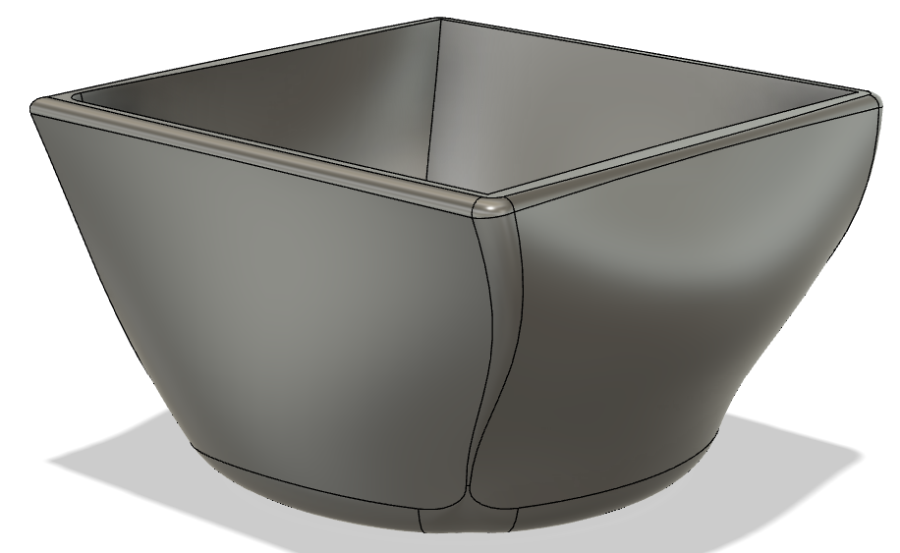
Lab 3 reference — target model / setting
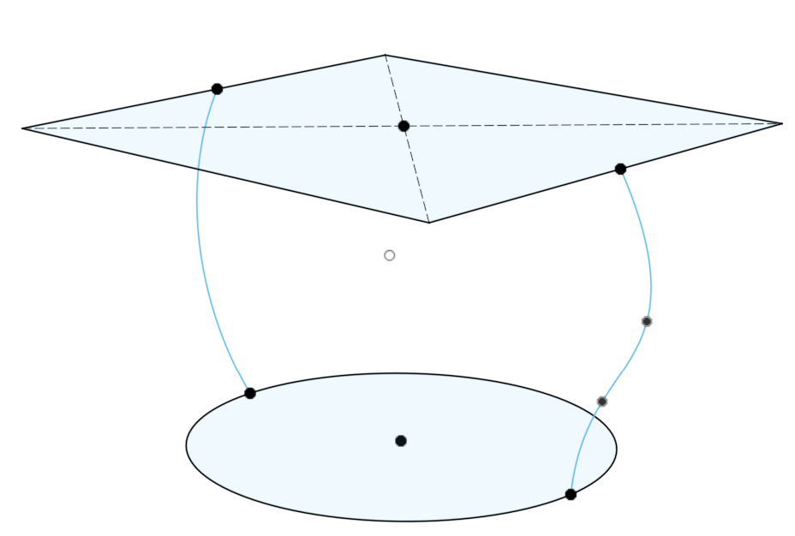
Lab 3 reference — as prepared in the tool
Step-by-step
- Sketch a 50 mm circle on the XY plane — this is the pot base.
Create Sketch ▸ Circle — Ø 50 mm ▸ Finish Sketch
- Create an offset plane 60 mm above the base and sketch a 60 mm square on it.
Construct ▸ Offset Plane — 60 mm ▸ Sketch ▸ Rectangle 60 × 60 mm
- Loft from the circle to the square; add guide rails between matching points to control the curve.
Create ▸ Loft — profiles: circle + square, rails: optional splines
- Shell the solid to a 2.5 mm wall, removing the top face, to hollow the pot.
Modify ▸ Shell — face: top, thickness 2.5 mm
- Export the pot as an STL file.
File ▸ Export ▸ STL
- Slice in Cura standing base-down; no supports are needed because the walls flare outward.
Cura ▸ Open File ▸ pot.stl ▸ Slice
- Print the pot and inspect the loft surface finish.
Cura ▸ Save to Disk ▸ print
Evidence to capture
- Fusion 360 screenshot showing both loft profiles, guide rails and the 2.5 mm shell.
- Cura Preview screenshot confirming base-down, support-free orientation.
- Photo or inspection note on wall continuity and the circle-to-square transition.
Test it
The pot prints support-free with an even 2.5 mm wall; the loft transition from circle to square is smooth with no layer separation.
Note: This lab lives in labs/lab-03-loft-mini-plant-pot/ together with any sample files it needs.

Lab 4 — Revolve — Funnel from a 2D Profile
TSC objective: A1 — apply the revolve technique and choose a print orientation that avoids supports.
Goal: Model a funnel in Fusion 360 by sketching its half cross-section and revolving it about the vertical axis, then invert it in Cura and 3D print it.
What you'll build
A working funnel revolved from a single 2D profile, printed wide-end down. (Tools: Fusion 360, Ultimaker Cura, FDM printer (PLA).)
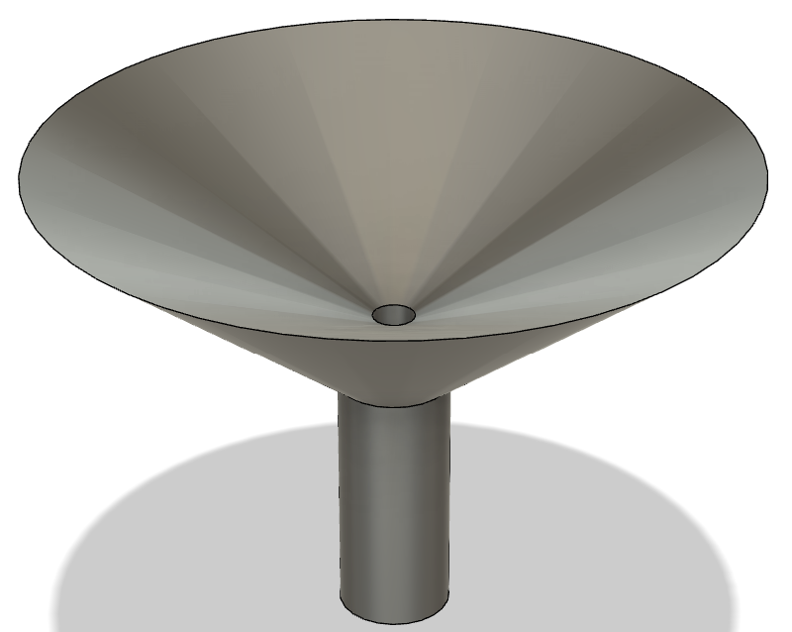
Lab 4 reference — target model / setting
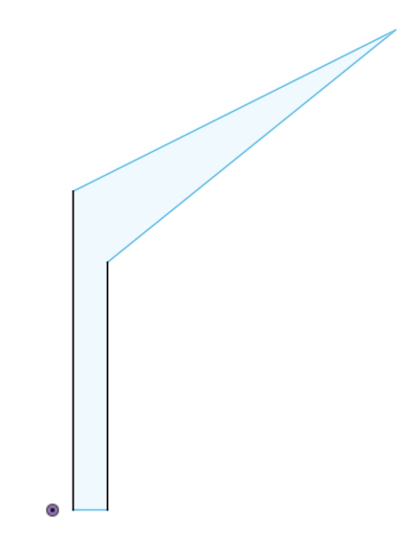
Lab 4 reference — as prepared in the tool
Step-by-step
- Sketch the funnel's half profile on the XZ plane: a wide cone tapering into a narrow spout, drawn as a closed outline 2 mm thick.
Create Sketch ▸ Line — cone Ø 60 mm → spout Ø 8 mm, wall 2 mm
- Revolve the profile 360° around the vertical (Z) axis to form the funnel body.
Create ▸ Revolve — profile: half section, axis: Z, angle 360°
- Check the wall is watertight and uniform using the Inspect ▸ Section Analysis tool.
Inspect ▸ Section Analysis
- Export the funnel as an STL file.
File ▸ Export ▸ STL
- Open it in Cura — it imports spout-up; rotate it so the wide mouth sits on the build plate.
Cura ▸ Rotate — 180° about X (wide end down)
- Slice and confirm the cone angle prints without supports, then print.
Cura ▸ Slice ▸ Preview ▸ Save to Disk
Evidence to capture
- Fusion 360 screenshot showing the closed half-profile and 360-degree revolve.
- Cura Preview screenshot confirming wide-end-down orientation and no supports.
- Photo or water-flow note confirming a clear, functional spout.
Test it
Sliced upside-down the funnel needs no supports; water poured into the printed funnel flows cleanly through the spout.
Note: This lab lives in labs/lab-04-revolve-funnel-from-a/ together with any sample files it needs.

Lab 5 — Tolerance — Container and Lid (0.2 mm Fit)
TSC objective: A1 — determine digital and physical tolerances between assembling parts.
Goal: Model a container and lid as two separate bodies in Fusion 360 with a 0.2 mm clearance, verify the digital tolerance, then 3D print and test the physical fit.
What you'll build
A two-part container whose lid slides on with a designed 0.2 mm clearance. (Tools: Fusion 360, Ultimaker Cura, FDM printer (PLA), digital calipers, supplied FDM Box reference files.)
Supplied model files
- FDM-Box-Final.f3d — Editable Fusion 360 reference model for design-history and clearance inspection.
- FDM-Box-Final.stl — Printable mesh for orientation, scale and fit comparison.
- FDM-Box-Cura.3mf — Cura project retaining the supplied slicer setup for comparison with your own profile.
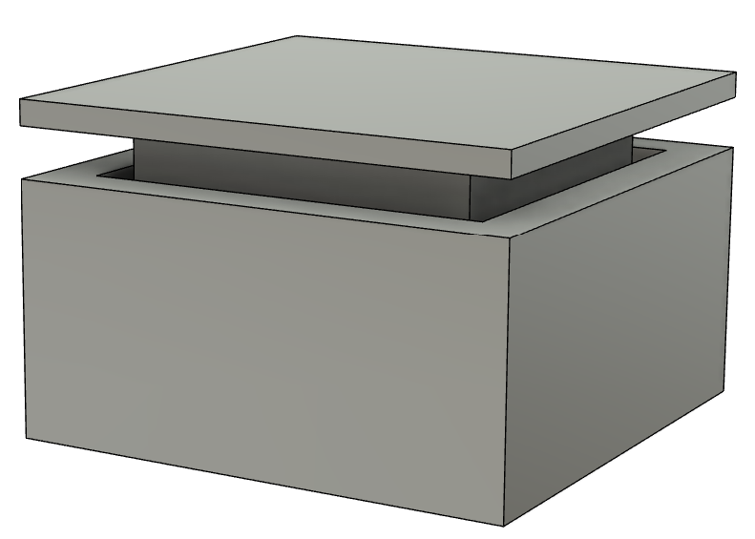
Lab 5 reference — target model / setting
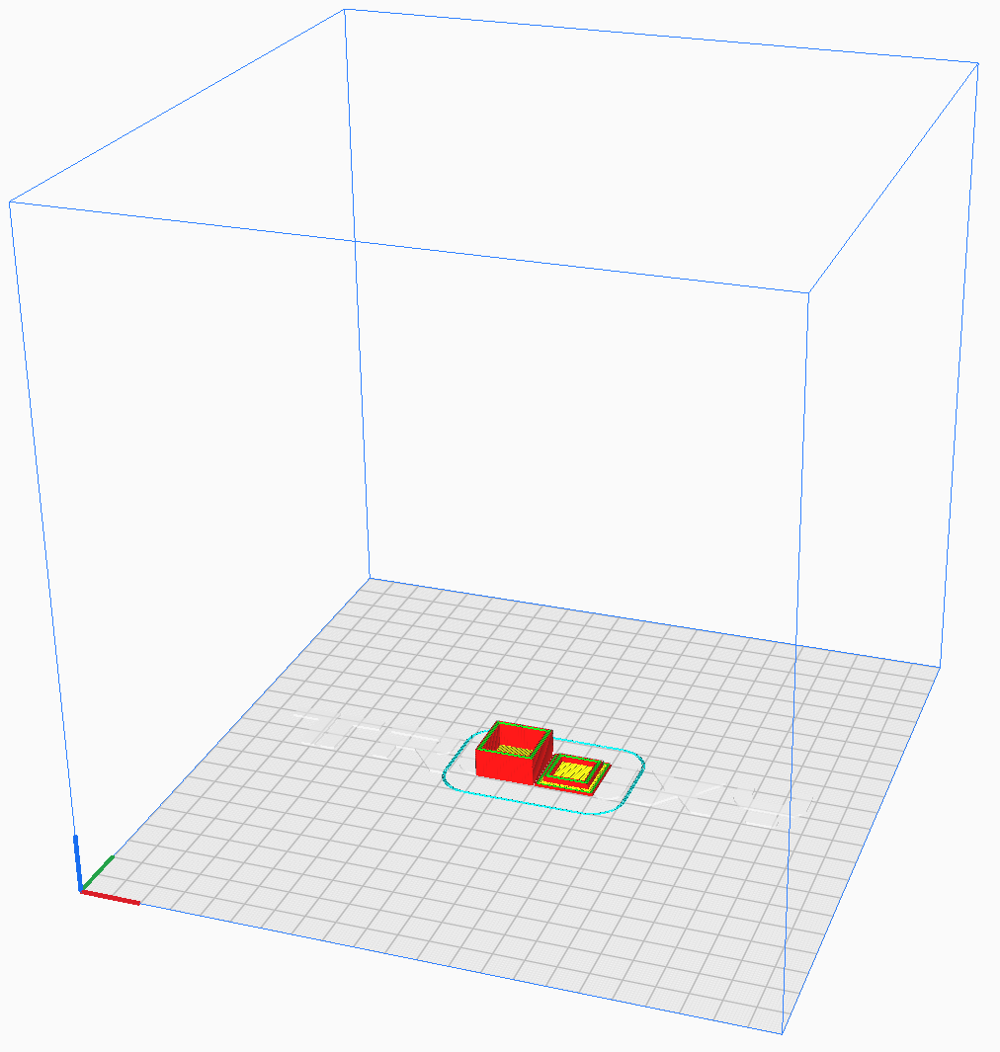
Lab 5 reference — as prepared in the tool
Step-by-step
- Model a 50 × 50 × 30 mm box and shell it to 2 mm walls with the top face removed.
Create ▸ Box 50×50×30 ▸ Modify ▸ Shell — 2 mm
- Model the lid as a second body: a 54 × 54 × 6 mm cap whose inner skirt is offset 0.2 mm from the box's outer wall.
Create ▸ Box (New Body) ▸ Modify ▸ Offset Faces — 0.2 mm clearance
- Measure the designed gap with the Inspect ▸ Measure tool to confirm 0.2 mm per side.
Inspect ▸ Measure — wall-to-skirt gap = 0.2 mm
- Export each body as its own STL file.
Right-click body ▸ Save As Mesh — container.stl, lid.stl
- In Cura, print the container open-end up; rotate the lid open-end up as well (invert it).
Cura ▸ Open Files ▸ Rotate lid 180°
- Slice and print both parts in one job.
Cura ▸ Slice ▸ Save to Disk ▸ print
- Measure the printed gap with digital calipers and test the fit.
Calipers: outer wall vs lid skirt — expect ≈0.2 mm/side
- Open FDM-Box-Final.f3d as a read-only reference and inspect how its bodies, wall thickness and clearances are organised; do not replace your own design with it.
Fusion 360 ▸ File ▸ Open ▸ FDM-Box-Final.f3d ▸ Inspect ▸ Measure
- Open FDM-Box-Cura.3mf and compare its saved orientation and slicer settings with your own job; record one setting you would retain and one you would change for your printer.
Cura ▸ File ▸ Open Project ▸ FDM-Box-Cura.3mf
Evidence to capture
- Screenshot of the 0.2 mm designed clearance measured in Fusion 360.
- Cura comparison showing your model and FDM-Box-Final.stl at the intended scale and orientation.
- Caliper readings and a short pass/fail note for the printed lid fit.
Test it
The lid slides onto the container with light friction — neither loose nor forced — and your evidence distinguishes the designed 0.2 mm clearance, the measured printed result and the supplied FDM Box reference setup.
Note: This lab lives in labs/lab-05-tolerance-container-and-lid/ together with any sample files it needs.

Lab 6 — 3D Scan and Print a Real Object
TSC objective: A4 — evaluate reverse engineering of a component through 3D scanning and subsequent AM.
Goal: Scan a real object with a mobile 3D-scanning app, export the mesh as an STL file, repair it if needed, then slice and 3D print the reproduction.
What you'll build
A 3D-printed reproduction of a real object captured by photogrammetry on your phone. (Tools: Polycam / Kiri Engine / Scandy Pro (mobile), Fusion 360, Ultimaker Cura.)
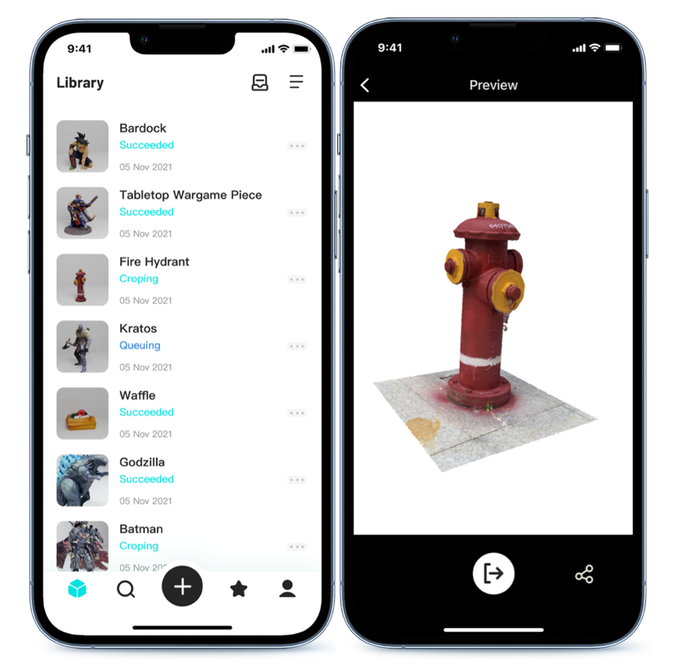
Lab 6 reference — target model / setting

Lab 6 reference — as prepared in the tool
Step-by-step
- Install a 3D scanning app on your phone — Polycam or Kiri Engine (Android/iOS), or Scandy Pro / Heges (iOS LiDAR).
App Store / Google Play ▸ Polycam or Kiri Engine
- Pick a matte, textured object about the size of a mug and place it on a contrasting background with even lighting.
Object: non-shiny, non-transparent, stable
- Capture 30–60 photos in two orbits around the object — one at eye level, one from above — keeping it centred.
App ▸ Photo mode ▸ capture 2 full orbits
- Let the app reconstruct the mesh, then crop away the background and floor plane.
App ▸ Process ▸ Crop / Remove floor
- Export the model as an STL (or OBJ, then convert via Fusion 360's Mesh workspace).
App ▸ Export ▸ STL
- Repair holes or stray triangles: Fusion 360 ▸ Mesh ▸ Repair, or import directly into Cura if clean.
Fusion 360 ▸ Mesh ▸ Repair ▸ Export STL
- Scale the model in Cura to a 20-minute print size (~40 mm tall), slice with supports if needed, and print.
Cura ▸ Scale 40 mm ▸ Slice ▸ print
Evidence to capture
- Screenshot of the cleaned scan with the floor/background removed.
- Mesh-repair evidence showing a watertight model that loads cleanly in Cura.
- Photo comparing the source object with the recognisable scaled print.
Test it
The exported STL loads into Cura as a watertight mesh, and the printed part is a recognisable scaled reproduction of the scanned object.
Note: This lab lives in labs/lab-06-3d-scan-and-print/ together with any sample files it needs.

Topic 02 — Process Related Issues for AM
Printer hardware · slicing · adhesion · extrusion · temperature · materials (K2, K4 · A2, A3)
Key concepts
- Five issue sources — Printer hardware, materials, printing process conditions, environment conditions and design-caused issues.
- Slicing — The slicer converts an STL model into G-code printer instructions — settings decide quality, time and strength.
- Bed adhesion — Geometry, nozzle distance, platform surface and platform temperature govern whether the first layer sticks.
- Extrusion issues — Over/under-extrusion, retraction, oozing and stringing — diagnosed from the printed surface.
- Temperature window — Each material has a working temperature band; too low fails adhesion, too high causes sag, strings and smells.
- Material requirements — ABS, PLA, PETG and Nylon each demand specific temperatures, beds, ventilation and storage.

Lab 7 — Install Cura and Slice Your First Model
TSC objective: A2 — set up the slicing toolchain used to analyse and fix AM process issues.
Goal: Install Ultimaker Cura, add your printer profile, and slice a calibration cube to understand how the slicer turns an STL into G-code printer instructions.
What you'll build
A working Cura installation with your printer profile, and your first sliced G-code file. (Tools: Ultimaker Cura, cube10.stl, cube20.stl.)
Supplied model files
- cube20.stl — 20 mm calibration cube for scale, dimensional and time/material comparisons.
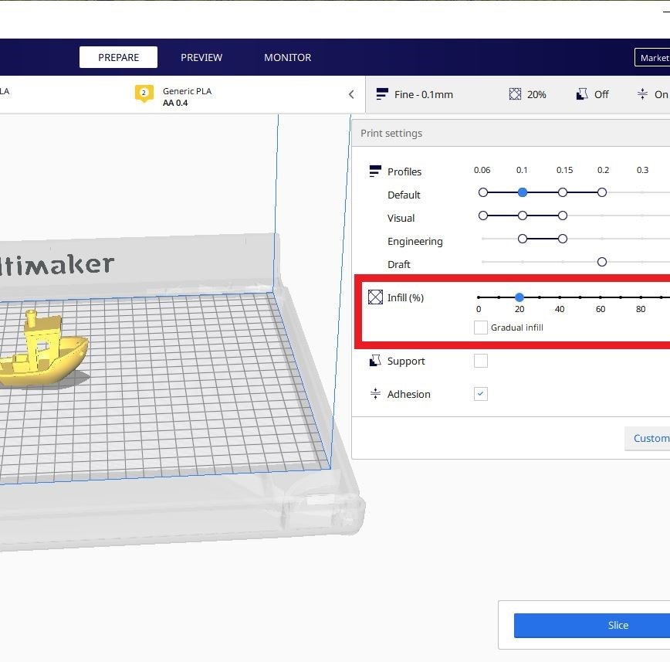
Lab 7 reference — target model / setting
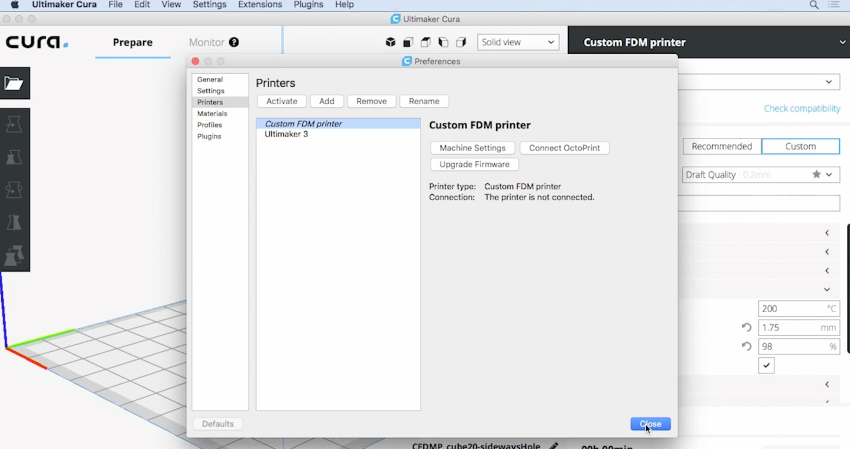
Lab 7 reference — as prepared in the tool
Step-by-step
- Download Ultimaker Cura for your operating system and run the installer.
https://ultimaker.com/software/ultimaker-cura
- Launch Cura and step through the first-run wizard; skip account sign-in if offered.
Cura ▸ Get Started
- Add your printer — pick the exact model, or 'Custom FFF printer' with your bed size and nozzle diameter.
Settings ▸ Printer ▸ Add Printer
- Open the sample cube from the lab folder.
File ▸ Open File(s) ▸ cube10.stl
- Select the Standard Quality 0.2 mm profile and note the default wall, infill, speed and temperature values.
Print Settings ▸ Profile — Standard Quality 0.2 mm
- Slice the model and read the estimated print time and material use.
Slice ▸ note time + grams
- Open the Preview tab and drag the layer slider to watch the toolpath layer by layer — walls, infill, travels.
Preview ▸ layer slider
- Save the G-code to disk (or SD card) — this file is the printer's complete instruction set.
Save to Disk ▸ cube10.gcode
- Repeat the slice with cube20.stl, confirm Cura reads it as 20 × 20 × 20 mm, and compare the time/material estimate with cube10.stl.
File ▸ Open File(s) ▸ cube20.stl ▸ Scale ▸ verify 20 mm on X/Y/Z
Evidence to capture
- Screenshot of cube20.stl in Cura Preview with walls, infill and travel moves visible.
- Recorded print-time and material estimates for both the 10 mm and 20 mm cubes.
Test it
Cura shows per-layer toolpaths for both cubes, cube20.stl measures 20 × 20 × 20 mm, and your comparison explains why doubling linear size increases print time and material by much more than two times.
Note: This lab lives in labs/lab-07-install-cura-and-slice/ together with any sample files it needs.

Lab 8 — Bed Adhesion — Skirt vs Brim vs Raft
TSC objective: A2 — analyse first-layer adhesion issues and select the correct adhesion aid.
Goal: Slice three instances of the same cube with a skirt, a brim and a raft, print them, and compare adhesion strength, removal effort and bottom-surface finish.
What you'll build
Three prints of cube10.stl demonstrating skirt, brim and raft — and a rule for when to use each. (Tools: Ultimaker Cura, cube10.stl, FDM printer.)
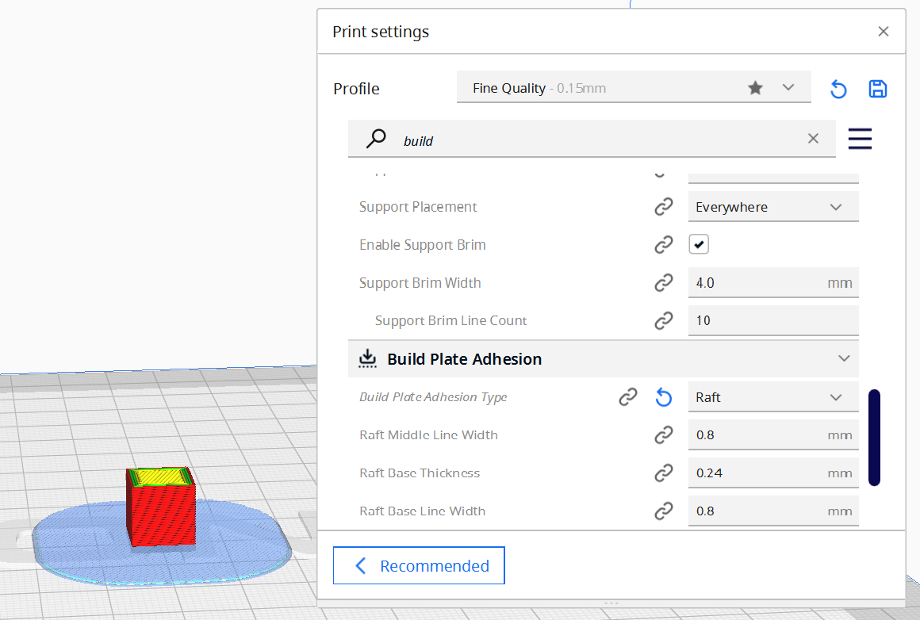
Lab 8 reference — target model / setting
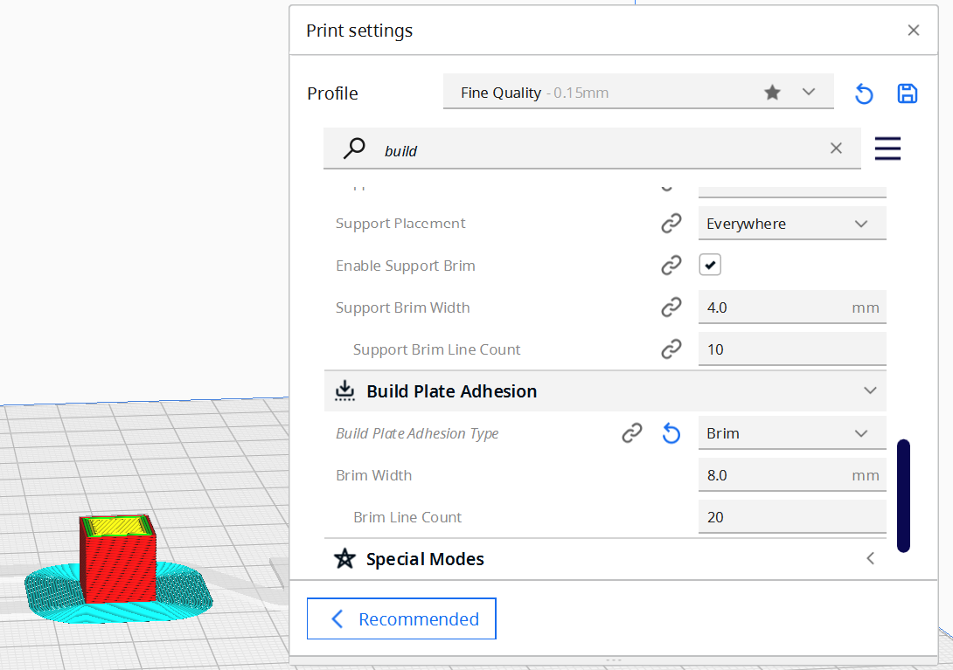
Lab 8 reference — as prepared in the tool
Step-by-step
- Open cube10.stl in Cura and duplicate it twice so three cubes sit on the plate.
Right-click ▸ Multiply Selected — 2 copies
- Select cube 1 and set Build Plate Adhesion to Skirt — a loop that primes the nozzle without touching the part.
Per Model Settings ▸ Build Plate Adhesion ▸ Skirt
- Select cube 2 and set adhesion to Brim, 8 mm — a flat border fused to the part's first layer.
Build Plate Adhesion ▸ Brim — width 8 mm
- Select cube 3 and set adhesion to Raft — a printed platform the part sits on.
Build Plate Adhesion ▸ Raft
- Slice and compare the three toolpaths in Preview; note the extra time and material the raft adds.
Slice ▸ Preview
- Print all three cubes in one job.
Save to Disk ▸ print
- Remove each cube: note how the skirt never touches, the brim peels off the edge, and the raft must be pried from the base.
Deburring tool / scraper
Evidence to capture
- Cura Preview screenshot showing the skirt, 8 mm brim and raft toolpaths.
- Recorded time/material estimate for each adhesion option.
- Photo or observation table comparing removal effort and bottom-surface finish.
Test it
You can state when each aid applies — skirt to prime the nozzle, brim for warping-prone or small-footprint parts, raft for top-heavy or poorly adhering parts — and show the bottom-finish difference.
Note: This lab lives in labs/lab-08-bed-adhesion-skirt-vs/ together with any sample files it needs.

Lab 9 — Support Structures for Overhangs
TSC objective: A2, A3 — determine when overhang geometry requires supports and generate them.
Goal: Use supplied twist, wedge and sideways-hole models to identify unsupported islands, compare orientation choices, then generate only the supports the geometry needs.
What you'll build
A support decision sheet plus a printed Twisted Solid whose critical overhangs succeed with controlled support use. (Tools: Ultimaker Cura, Twisted-Solid.stl, wedge.stl, cube20-sideways-hole.stl, FDM printer.)
Supplied model files
- Twisted-Solid.stl — 49 mm twisted benchmark with steep faces and changing overhangs.
- wedge.stl — Simple 60 mm overhang-angle benchmark for reading progressive underside quality.
- cube20-sideways-hole.stl — Sideways-hole benchmark for comparing support, bridging and reorientation.
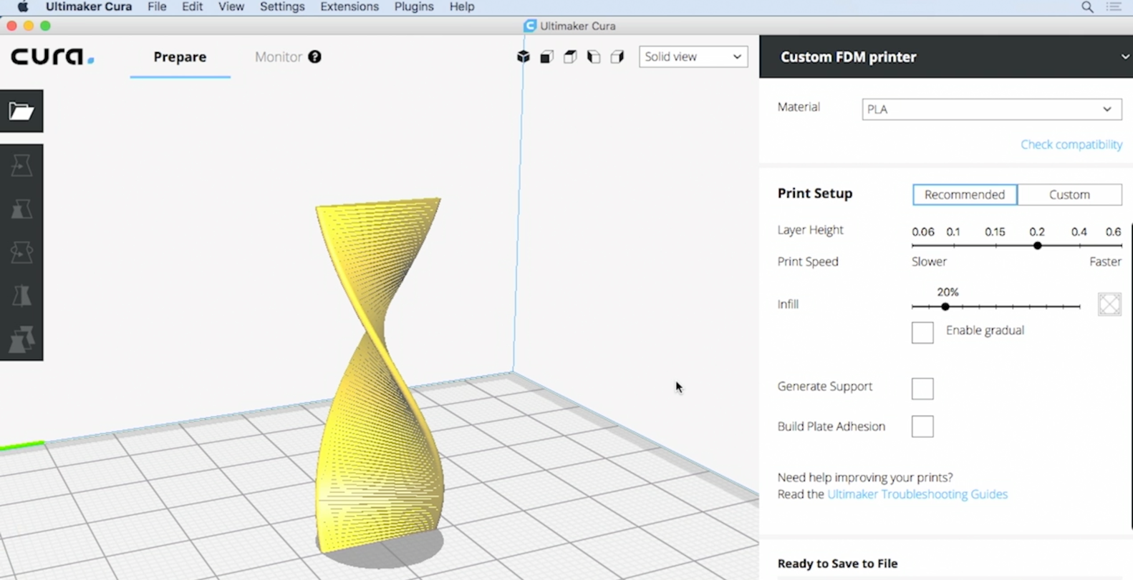
Lab 9 reference — target model / setting
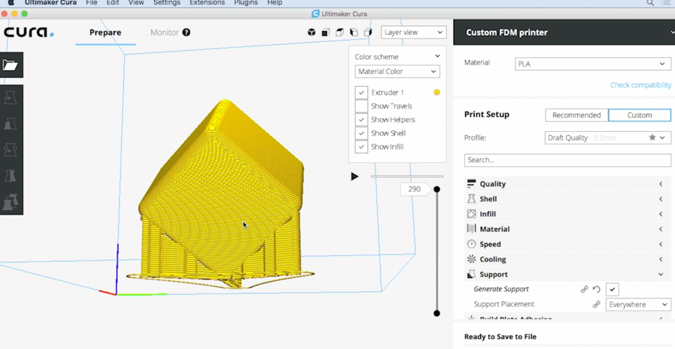
Lab 9 reference — as prepared in the tool
Step-by-step
- Open Twisted-Solid.stl in Cura and slice it with supports off.
File ▸ Open ▸ Twisted-Solid.stl ▸ Slice
- In Preview, find the layers that start in mid-air — these overhangs would droop or fail.
Preview ▸ layer slider — spot unsupported islands
- Enable support generation.
Print Settings ▸ Support ▸ Generate Support ✔
- Set placement to Touching Buildplate first; compare with Everywhere and note the difference in Preview.
Support Placement — Touching Buildplate vs Everywhere
- Keep the support overhang angle at 45–50° so only genuinely steep faces get support.
Support Overhang Angle — 50°
- Slice again and compare time and material with the unsupported version, then print.
Slice ▸ Save to Disk ▸ print
- Snap the supports off with pliers, working from the edges inward, and inspect the supported surfaces.
Needle-nose pliers ▸ remove supports
- Repeat the analysis with wedge.stl and cube20-sideways-hole.stl; for each, compare adding support with rotating the model to make the geometry self-supporting.
Open both models ▸ Rotate ▸ Slice ▸ Preview ▸ record decision
Evidence to capture
- Three-model support decision table: risk, best orientation, support placement and reason.
- Before/after Cura Preview screenshots for Twisted-Solid.stl with supports off and on.
- Photo of the printed benchmark after support removal, with scarring annotated.
Test it
Your decision table correctly identifies unsupported islands and distinguishes when support is necessary from when reorientation is the better fix; the Twisted Solid print completes with removable support and only minor underside scarring.
Note: This lab lives in labs/lab-09-support-structures-for-overhangs/ together with any sample files it needs.

Lab 10 — Filament Diagnostics — Diameter, Temperature and Flow
TSC objective: A2, A3 — analyse material-side causes of extrusion issues and verify filament quality.
Goal: Measure filament diameter with digital calipers, verify it against the slicer's material setting, and run a temperature check to place your filament in its working window.
What you'll build
A verified filament profile plus retraction and cooling evidence from purpose-built diagnostic models. (Tools: Digital calipers, filament spool (PLA/ABS/PETG), Ultimaker Cura, retraction-test.stl, cooling-spire.stl, FDM printer.)
Supplied model files
- retraction-test.stl — Multi-tower benchmark that exposes stringing during travel moves.
- cooling-spire.stl — Tall narrowing spire that reveals insufficient layer cooling.
- twist-with-cooling-tower.stl — Combined geometry for observing minimum-layer-time and cooling behaviour.
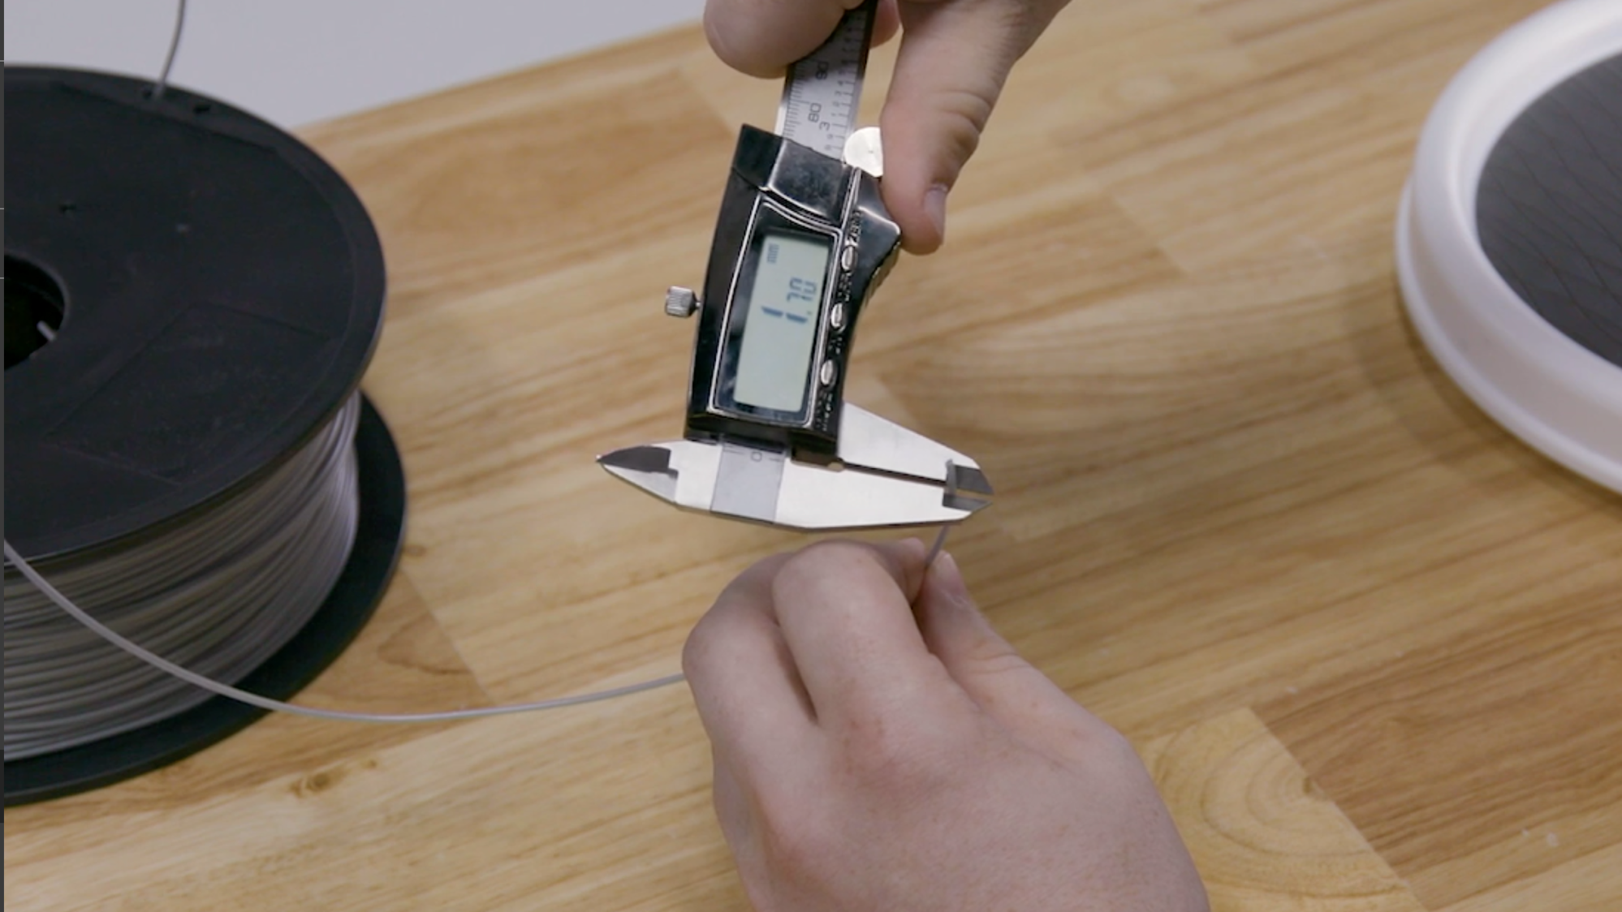
Lab 10 reference — target model / setting
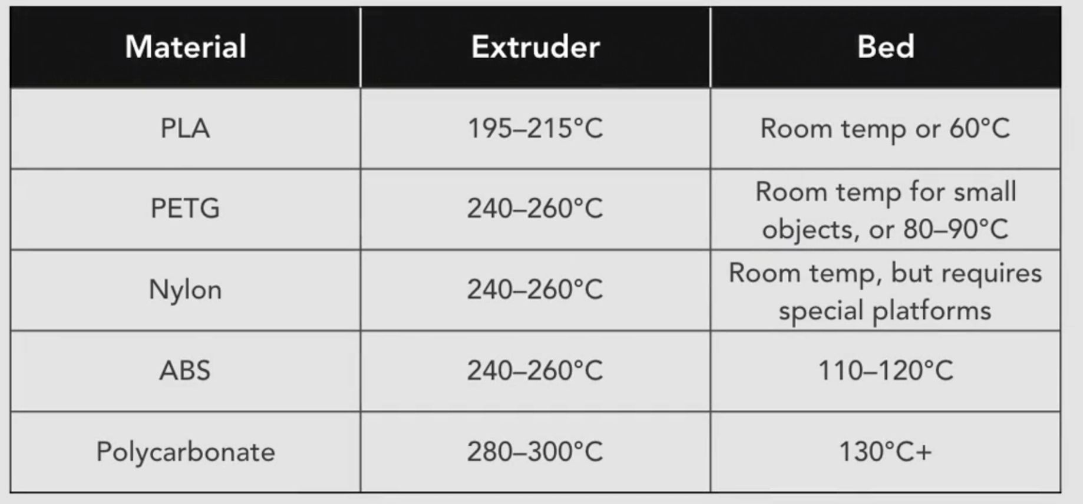
Lab 10 reference — as prepared in the tool
Step-by-step
- Cut off about 30 cm of filament from the spool end.
Flush cutters — ~30 cm sample
- Measure the diameter with digital calipers at five points along the sample, rotating the filament at each point.
Calipers — 5 readings, 2 orientations each
- Average the readings; a good 1.75 mm filament stays within ±0.05 mm.
Expect 1.70–1.80 mm
- Enter the measured diameter in Cura's material settings so flow is computed from reality, not the label.
Print Settings ▸ Material ▸ Diameter — measured value
- Check the material's temperature window: PLA 195–215 °C, PETG 240–260 °C, ABS 240–260 °C, Nylon 240–260 °C.
Material box / temperature table
- Set the printing temperature to the middle of the window and print a small test cube; drop 5 °C if strings appear, raise 5 °C if layers don't bond.
Material ▸ Printing Temperature — tune in 5 °C steps
- Watch the first layers: clicking from the extruder or ground filament means the temperature is too low or the nozzle is partially blocked.
Listen: extruder clicks = under-extrusion warning
- Slice retraction-test.stl with your baseline retraction, then change only one variable at a time (distance or speed); compare strings without masking jams or surface dimples.
Retraction ▸ record distance + speed ▸ Preview ▸ optional test print
- Slice cooling-spire.stl or twist-with-cooling-tower.stl and compare the upper layers with minimum layer time/fan control enabled and disabled.
Cooling ▸ Enable Print Cooling ▸ Minimum Layer Time ▸ compare tip quality
Evidence to capture
- Five filament-diameter readings and the calculated average.
- Retraction matrix recording distance, speed, stringing and surface defects.
- Cooling comparison recording fan/minimum-layer-time settings and tip quality.
Test it
Your diameter average is within ±0.05 mm of nominal, Cura carries the measured value, and the diagnostic models support a retraction/cooling choice with less stringing and a cleaner spire without introducing gaps or jams.
Note: This lab lives in labs/lab-10-filament-diagnostics-diameter-temperature/ together with any sample files it needs.

Topic 03 — Process Improvement for AM
Infill · surface quality · supports · post-processing · business impact (K5, K7 · A5, A6)
Key concepts
- Infill optimisation — Perimeters, infill pattern and density trade strength against material use and print time.
- Surface quality — Layer height, top thickness, ironing and fuzzy skin control the finish and the print duration.
- Support strategy — Orient parts to minimise supports; add them only where overhangs demand, and plan their removal.
- Post-processing — FDM, SLS, SLA and metal parts each have a defined finishing chain — from support removal to plating.
- Business impact — Measure speed, quality, material use, cost and user feedback before and after every process change.
- Sustainability — Calibration, training, sustainable materials and stakeholder collaboration keep AM operations viable long-term.

Lab 11 — Perimeters and Infill — Strength vs Speed
TSC objective: A5, A6 — apply wall/infill optimisation and assess its measured impact on time and material.
Goal: Vary wall count and infill density on the same model in Cura, and record how each change moves print time, material use and expected strength.
What you'll build
A comparison table of wall/infill settings against sliced print time and material grams. (Tools: Ultimaker Cura, cube10.stl, line-width-test.stl, cube20 hole-wall variants.)
Supplied model files
- line-width-test.stl — Thin-wall benchmark for nozzle/line-width and single-wall behaviour.
- cube20-hole-0-wall.stl — Hole benchmark with the wall-control baseline geometry.
- cube20-hole-1-wall.stl — Matched hole benchmark for testing the effect of an additional wall.
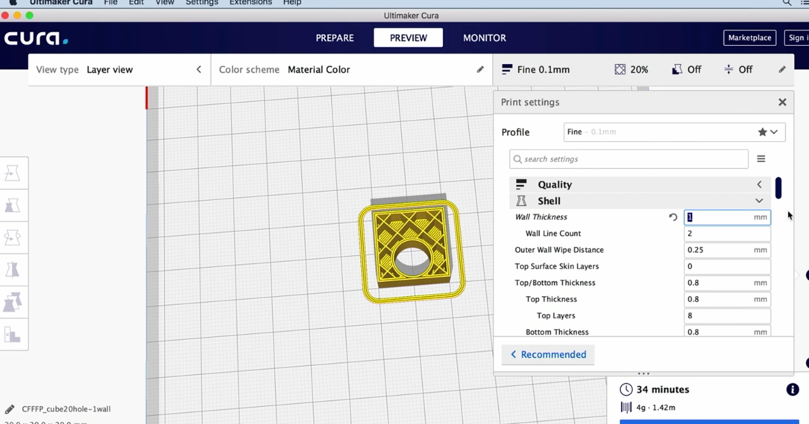
Lab 11 reference — target model / setting
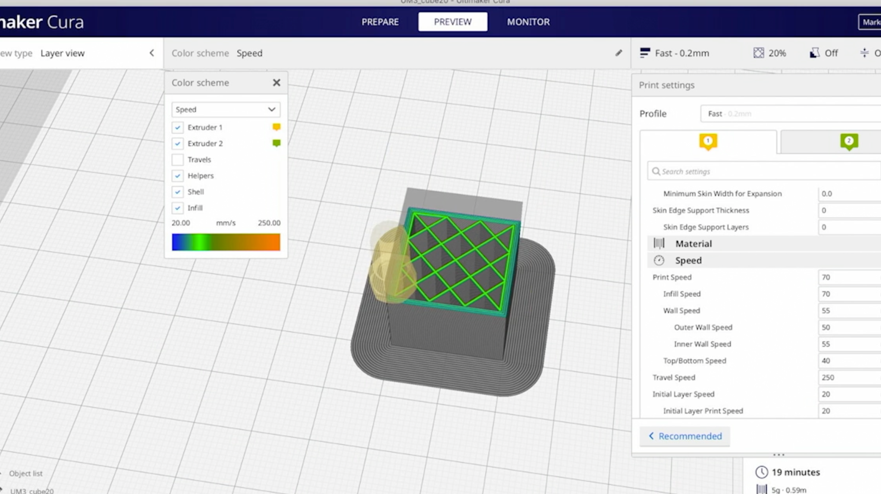
Lab 11 reference — as prepared in the tool
Step-by-step
- Open cube10.stl and slice with the defaults — 2 walls, 20% infill; record time and grams.
Slice ▸ record: baseline
- Raise the wall line count to 4 and re-slice; record the change.
Print Settings ▸ Walls ▸ Wall Line Count — 4
- Reset walls to 2, then set infill density to 12% and re-slice; record.
Infill ▸ Density — 12%
- Set infill density to 50% and re-slice; record.
Infill ▸ Density — 50%
- In Preview, inspect how the infill lattice and wall thickness change at each setting.
Preview ▸ layer slider
- Tabulate the four runs: time, grams, and where the strength actually comes from (walls more than infill).
Table: setting → time → grams
- Open line-width-test.stl and the two cube20 hole-wall variants; inspect Preview for missing thin features, then record the smallest feature and hole wall your profile resolves continuously.
Open three diagnostic models ▸ Preview ▸ Color Scheme: Line Type
Evidence to capture
- Wall/infill table with time, material and expected load-path notes.
- Cura Preview comparison of the line-width and matched hole-wall models.
- Measured hole diameter and wall thickness from any printed benchmark.
Test it
Your evidence separates wall-count, infill and line-width effects; the matched hole models show how wall planning changes continuity and dimensional accuracy, and you can justify settings for functional versus decorative parts.
Note: This lab lives in labs/lab-11-perimeters-and-infill-strength/ together with any sample files it needs.

Lab 12 — Infill Patterns — Zigzag vs Grid Strength Test
TSC objective: A5 — evaluate infill pattern and density as a quality-improvement technique.
Goal: Print cube10.stl with zigzag 20% and grid 30% infill, tune the top layers, then compare the two cubes' stiffness by hand.
What you'll build
Two printed cubes with different infill patterns/densities and a hands-on strength comparison. (Tools: Ultimaker Cura, cube10.stl, Optimize1–4 model set, FDM printer.)
Supplied model files
- optimize-1.stl — Complex baseline part for printability and support-cost review.
- optimize-2.stl — Wide low-profile variant for build-orientation comparison.
- optimize-3.stl — Twisted variant for support and toolpath comparison.
- optimize-4.stl — Compact variant for rapid slicing and material-use comparison.
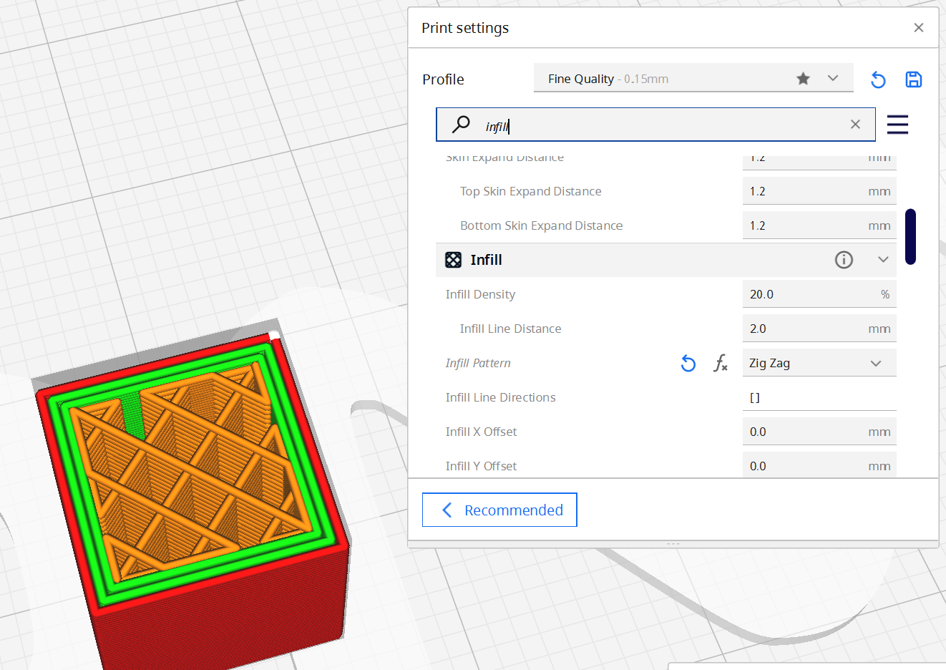
Lab 12 reference — target model / setting
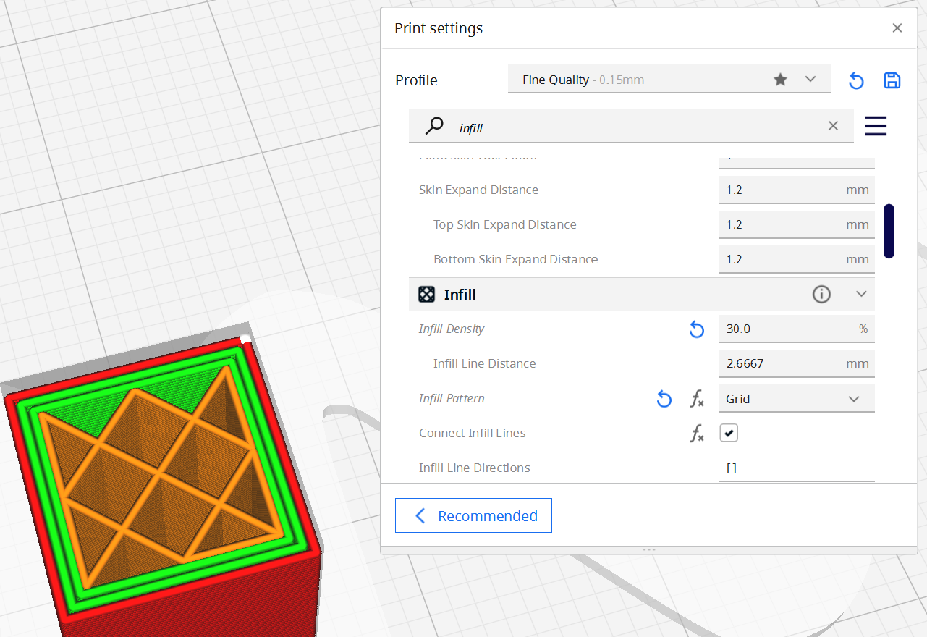
Lab 12 reference — as prepared in the tool
Step-by-step
- Open cube10.stl and set infill pattern to Zigzag at 20% density.
Infill ▸ Pattern — Zigzag, Density — 20%
- Set top layers to 4 so the roof closes cleanly over the infill.
Top/Bottom ▸ Top Layers — 4
- Slice, save and print the first cube.
Slice ▸ Save to Disk ▸ print
- Change the pattern to Grid at 30% density and re-slice; note the time difference.
Infill ▸ Pattern — Grid, Density — 30%
- Print the second cube.
Save to Disk ▸ print
- Compare the cubes: squeeze the walls, press the top faces, and note pillowing or gaps over the infill.
Hand test: wall flex + roof sag
- Load optimize-1.stl through optimize-4.stl, orient each for minimum support, and record Cura's estimated time/material before choosing the most efficient printable variant.
Open four models ▸ Auto Orient/Rotate ▸ Slice ▸ record estimates
Evidence to capture
- Optimisation scorecard for all four supplied variants: orientation, support volume, time and material.
- A justified selection of the best variant/settings for the stated business need.
Test it
The grid 30% cube is stiffer and better supported, while your four-variant scorecard shows that geometry and orientation can outweigh infill choice; your final recommendation is backed by time, material and support evidence.
Note: This lab lives in labs/lab-12-infill-patterns-zigzag-vs/ together with any sample files it needs.

Lab 13 — Layer Height and Top Thickness — Surface Quality
TSC objective: A5 — optimise layer height and top thickness for surface quality vs speed.
Goal: Slice the same model at 0.1 mm, 0.2 mm and 0.3 mm layer heights, adjust top thickness to a constant, and compare surface quality against print time.
What you'll build
Sliced (and optionally printed) evidence of the layer-height ladder: finish vs time. (Tools: Ultimaker Cura, cube10.stl, sloped-cube.stl, FDM printer.)
Supplied model files
- sloped-cube.stl — Sloped-face benchmark that makes layer-height stair-stepping easy to compare.
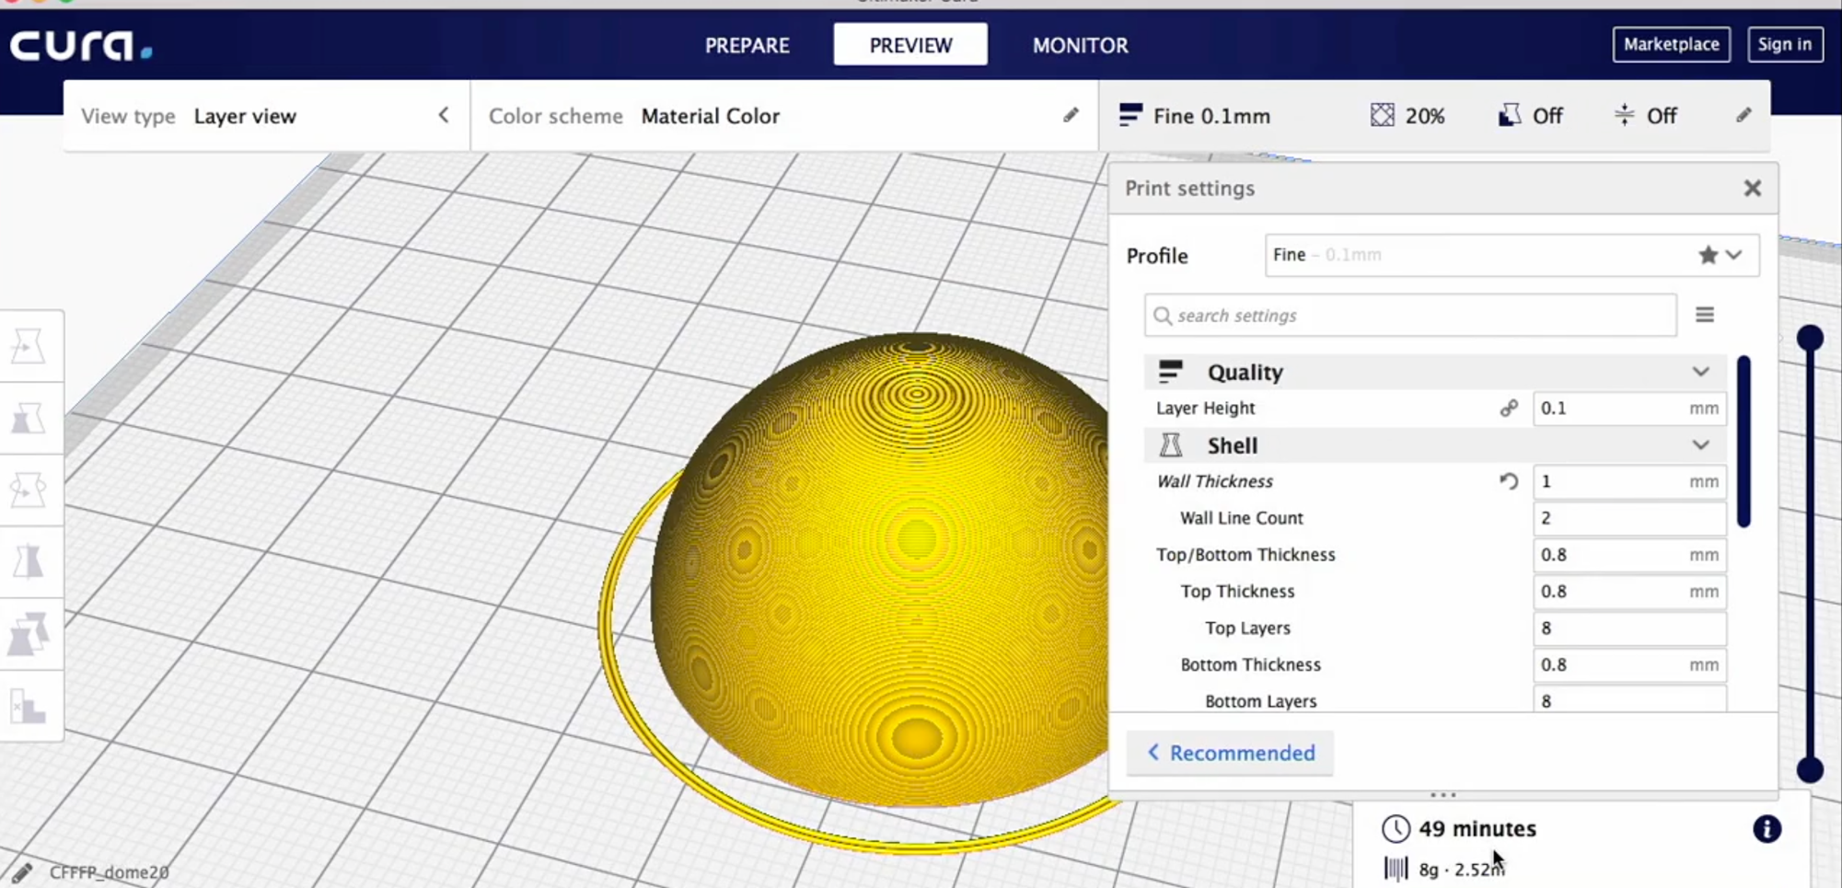
Lab 13 reference — target model / setting
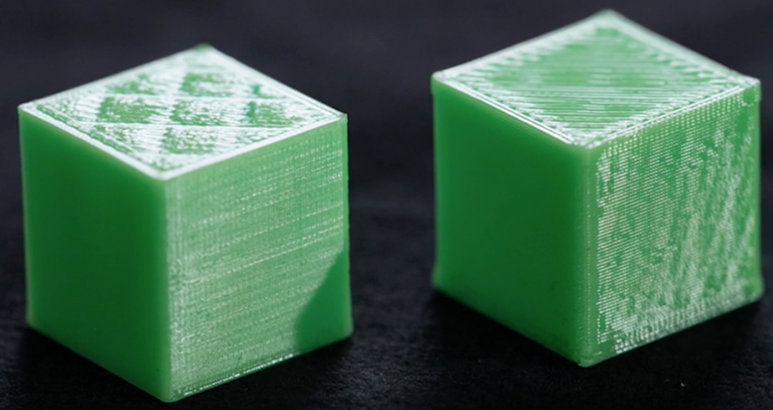
Lab 13 reference — as prepared in the tool
Step-by-step
- Open cube10.stl and slice at 0.2 mm layer height; record the time.
Quality ▸ Layer Height — 0.2 mm
- Slice at 0.1 mm; note the doubled layer count and time.
Layer Height — 0.1 mm
- Slice at 0.3 mm; note the coarser stairs and the reduced time.
Layer Height — 0.3 mm
- Keep top thickness constant at 0.8 mm — so the TOP LAYER COUNT changes with layer height (8 / 4 / 3 layers).
Top/Bottom ▸ Top Thickness — 0.8 mm
- In Preview, compare side-wall stair-stepping and the roof at each height.
Preview ▸ compare walls + roof
- Print the 0.1 mm and 0.3 mm cubes and compare finish by eye and touch.
print both
- Repeat the three slices with sloped-cube.stl and zoom into the sloped face; this geometry makes the staircase effect visible in Preview before printing.
Open sloped-cube.stl ▸ Slice at 0.1 / 0.2 / 0.3 mm ▸ compare
Evidence to capture
- Three-row layer-height table with layer count, print time and observed stair-stepping.
- Matched Preview screenshots of the sloped face at 0.1, 0.2 and 0.3 mm.
Test it
You can rank the layer heights by finish and time, point to visible stair-stepping on sloped-cube.stl, and explain why constant top thickness—not a fixed top-layer count—keeps the comparison fair.
Note: This lab lives in labs/lab-13-layer-height-and-top/ together with any sample files it needs.

Lab 14 — Ironing — Glass-Smooth Top Surfaces
TSC objective: A5 — apply ironing to improve top-surface quality and assess its cost.
Goal: Enable Cura's ironing feature, which passes the hot nozzle over the top surface with a tiny extrusion, and compare the top finish with and without it.
What you'll build
Two cube prints — ironed and standard — demonstrating the top-surface improvement. (Tools: Ultimaker Cura, cube10.stl, z-block.stl, FDM printer.)
Supplied model files
- z-block.stl — Detailed top-surface benchmark for evaluating ironing around raised geometry.
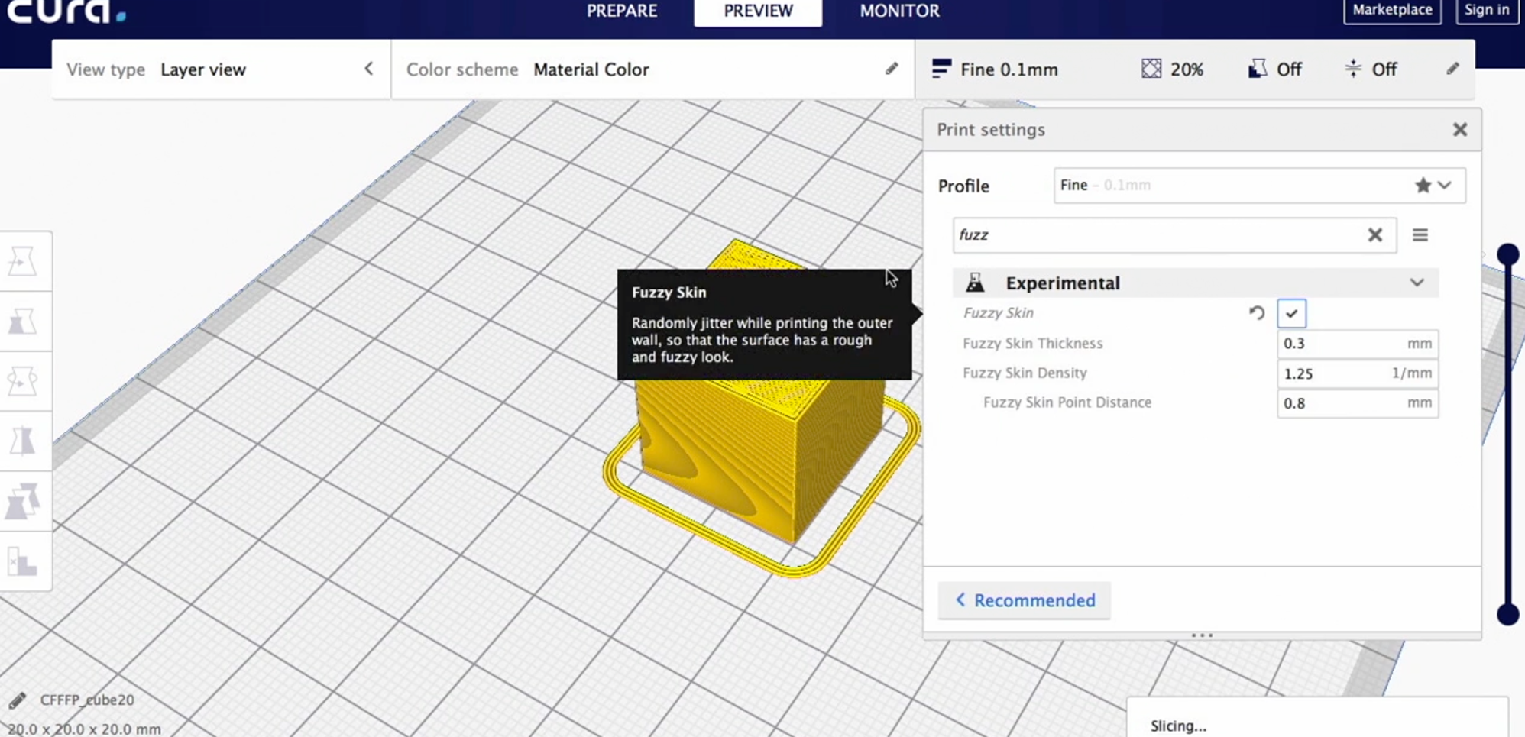
Lab 14 reference — target model / setting
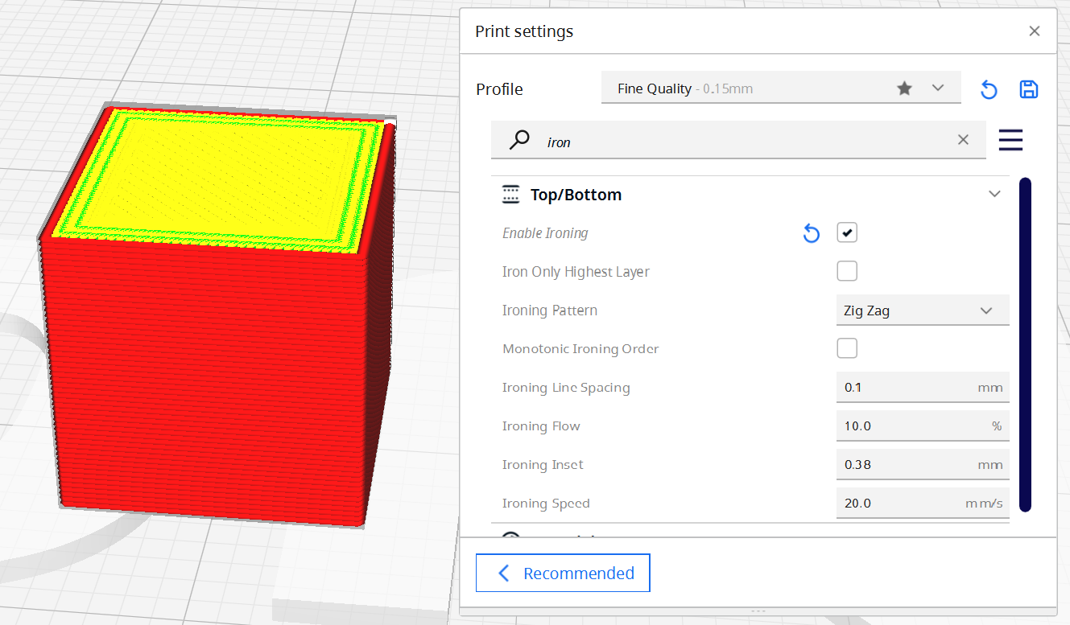
Lab 14 reference — as prepared in the tool
Step-by-step
- Open cube10.stl and slice with the standard 0.2 mm profile; print cube 1 as the control.
Slice ▸ print control cube
- Enable ironing.
Top/Bottom ▸ Enable Ironing ✔
- Inspect the ironing pass in Preview — a dense zigzag over the top face at ~10% flow.
Preview ▸ top layer ▸ ironing pass
- Slice and note the added time (ironing is slow but only on top faces).
Slice ▸ record extra minutes
- Print cube 2 with ironing enabled.
Save to Disk ▸ print
- Compare the two top faces under raking light: the ironed face should be near-flat with faint tool lines.
Visual + touch comparison
- Repeat the Preview comparison with z-block.stl to inspect how ironing travels around raised detail; print it only if time permits.
Open z-block.stl ▸ Enable Ironing ▸ Preview top layers
Evidence to capture
- Control-versus-ironed time/material record.
- Raking-light photos comparing the flat and detailed top surfaces.
Test it
The ironed cube is visibly smoother than the control, z-block.stl shows ironing constrained to eligible top faces, and you can justify the added time for lids, logos and presentation surfaces.
Note: This lab lives in labs/lab-14-ironing-glass-smooth-top/ together with any sample files it needs.

Lab 15 — Fuzzy Skin — Textured Walls on a Vase
TSC objective: A5 — apply fuzzy skin as a deliberate surface-texture treatment.
Goal: Enable fuzzy skin on a vase model so the outer wall is jittered into a stone-like texture that hides layer lines, and print it with buildplate adhesion.
What you'll build
A vase with a uniform fuzzy texture that masks layer lines completely. (Tools: Ultimaker Cura, open vase.stl, 1.5mm-wall-vase.stl, FDM printer.)
Supplied model files
- 1.5mm-wall-vase.stl — Thin-walled vase benchmark for comparing fuzzy skin with wall-thickness constraints.
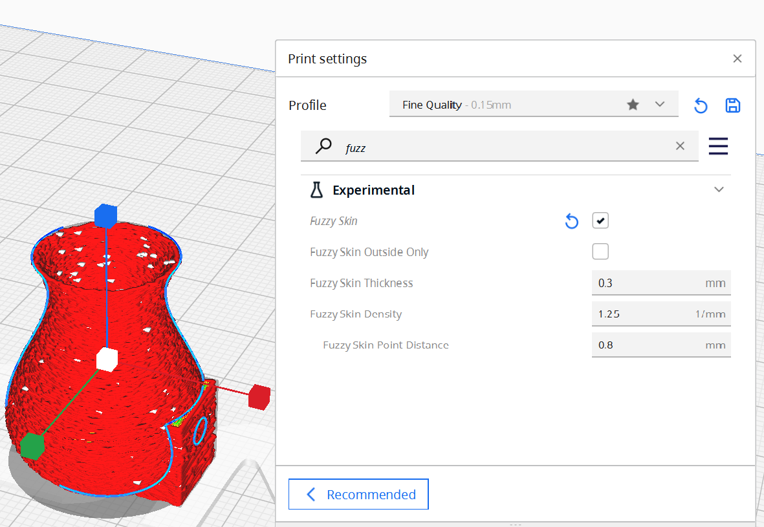
Lab 15 reference — target model / setting
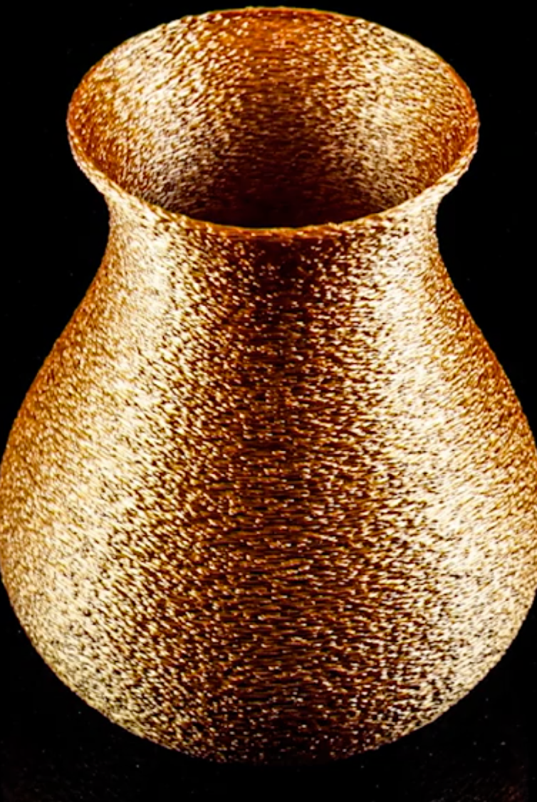
Lab 15 reference — as prepared in the tool
Step-by-step
- Open 'open vase.stl' in Cura.
File ▸ Open ▸ open vase.stl
- Enable fuzzy skin — the slicer adds random jitter to the outer wall toolpath.
Experimental ▸ Fuzzy Skin ✔
- Set fuzzy skin thickness to 0.3 mm and density to 1.25/mm for a fine stone texture.
Fuzzy Skin Thickness 0.3 mm · Density 1.25
- Add a brim so the tall thin vase stays anchored.
Build Plate Adhesion ▸ Brim
- Slice and inspect the jittered outer wall in Preview.
Slice ▸ Preview ▸ outer wall
- Print the vase and examine the texture — layer lines should be invisible within the fuzz.
print + inspect
- Open 1.5mm-wall-vase.stl and verify the chosen fuzzy-skin thickness will not consume the thin wall; reduce the effect if Preview shows unstable or missing wall paths.
Open 1.5mm-wall-vase.stl ▸ Preview ▸ Line Type ▸ inspect wall continuity
Evidence to capture
- Cura Preview showing fuzzy-skin jitter and the 1.5 mm wall toolpaths.
- Close-up photo and tactile assessment of the finished texture.
Test it
The printed vase carries an even tactile texture, and the 1.5 mm diagnostic vase retains continuous walls in Preview—showing that the texture setting fits the available wall thickness.
Note: This lab lives in labs/lab-15-fuzzy-skin-textured-walls/ together with any sample files it needs.

Lab 16 — Post-Processing — Support Removal and Sanding
TSC objective: A5 — apply post-processing to lift the quality of an FDM part.
Goal: Print the vase tilted so it needs supports, remove them cleanly, then sand the scarred surfaces through progressive grits to a smooth finish.
What you'll build
A tilted-print vase taken from raw support-scarred print to a smooth finished part. (Tools: Ultimaker Cura, open vase.stl, test-part.stl, FDM printer, pliers, sandpaper 120→400 grit.)
Supplied model files
- test-part.stl — Mixed-feature benchmark for planning support removal and progressive finishing.
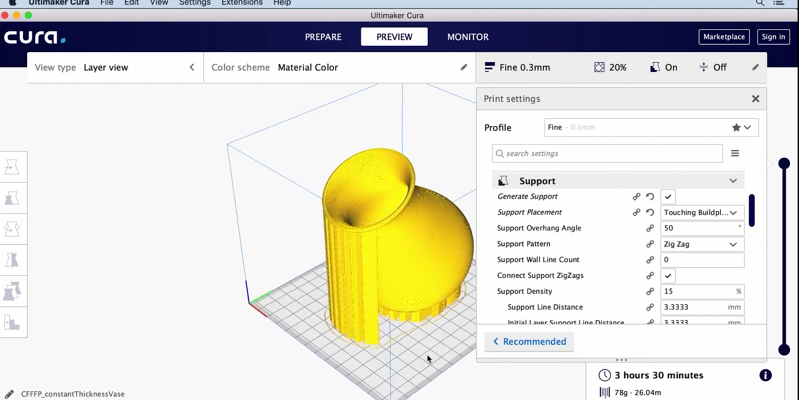
Lab 16 reference — target model / setting
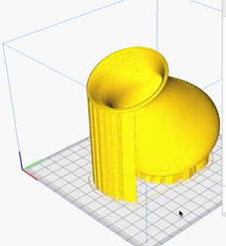
Lab 16 reference — as prepared in the tool
Step-by-step
- Open 'open vase.stl' in Cura and rotate it 15–20° off vertical so one side overhangs.
Rotate — 15–20° tilt
- Enable supports (Touching Buildplate) and slice.
Support ▸ Generate ✔ ▸ Touching Buildplate
- Print the tilted vase with its supports.
Save to Disk ▸ print
- Snap the supports off with pliers, working from the outer edge toward the part.
Needle-nose pliers
- Sand the support-scarred areas with 120-grit, then step through 240 → 400 grit in circular motions.
Sandpaper 120 → 240 → 400
- Optionally wet-sand at 400 grit for a satin finish, and compare the treated side with an untouched area.
Wet sand + compare
- Inspect test-part.stl in Cura and write a finishing plan before printing: support access, tool order, surfaces to protect and dimensions that sanding must not change.
Open test-part.stl ▸ Preview supports ▸ annotate finishing plan
Evidence to capture
- Annotated before/after photographs of support scars and the sanded surface.
- Finishing log with tools, grit sequence, time and observed dimensional/detail loss.
Test it
The support side is smooth from a normal viewing distance, and your evidence shows a planned 120→240→400 grit process that removes scars without rounding protected features or critical dimensions.
Note: This lab lives in labs/lab-16-post-processing-support-removal/ together with any sample files it needs.

Revision — What to Master for the Assessment
Knowledge (Written Assessment, K1–K7)
- K1 — AM characteristics: layer-by-layer construction from CAD, design freedom, rapid prototyping, no part-specific tooling; the 7 ISO/ASTM process families and DMLS/SLS/SLM.
- K2 — Process requirements: correct material choice (PLA/ABS/PETG/Nylon/resins), temperature windows, build environment (draughts, humidity, vibration), calibrated and maintained printers.
- K3 — Selection factors: material properties, design complexity, production volume and speed, post-processing needs, cost.
- K4 — Impact on operations: no tooling/molds, shorter development cycles, complex geometry, customisation without cost, less waste, distributed manufacturing.
- K5 — Performance review methods: dimensional accuracy and tolerance checks, surface-finish evaluation, material property tests, build speed/throughput, cost per part.
- K6 — Benefits vs trade-offs: rapid prototyping, design flexibility, low waste, customisation — against bulk-production cost, material limits, post-processing load, anisotropic strength.
- K7 — Sustainability: operator training, equipment calibration/maintenance, recycling and circular material use, sustainable-material R&D, stakeholder collaboration on standards.
Application (Practical Performance, A1–A6)
- A1 — Material and design analysis: mechanical/thermal properties, stress points, load-bearing needs, AM-process compatibility, post-processing and surface treatments.
- A2 — Process issues: DMLS warping/powder inconsistency; SLS incomplete sintering/thermal distortion; SLM oxidation/residual stress; powder-bed spreading and recycling; inkjet nozzle clogs and layer misalignment.
- A3 — Processes and procedures: DMLS/SLM for metals, FDM/SLS for non-metals, separate post-processing per material, bonding techniques (e.g. electroless deposition) for hybrid parts, integrity testing.
- A4 — Reverse engineering: scan → refine mesh to CAD → repair wear digitally → select AM process → manufacture and post-process.
- A5 — Optimisation: layer height/orientation, walls/infill tuning, machine calibration, support optimisation, surface treatments (ironing, fuzzy skin), real-time monitoring and simulation.
- A6 — Impact assessment: baseline → change → measure → compare → decide, across production speed, material use/wastage, quality (accuracy, finish, properties), resource utilisation, cost and operator feedback.
Practice
- Course portal (slides, guide, assessment submission): https://lms-tms.tertiaryinfotech.com
- Redo each lab's Test-it check from memory — the practical assessment mirrors the lab skills.
- Use the supplied diagnostic STL files to explain what each geometry reveals before changing a slicer setting.

Glossary
- Additive Manufacturing (AM) — Building parts layer by layer directly from a CAD file — the industrial discipline around 3D printing.
- STL — The mesh file format (triangles) exported from CAD and consumed by slicers.
- G-code — The movement/temperature/extrusion command language slicers output and printers execute.
- Slicer — Software (e.g. Cura) that converts a 3D model into layer-by-layer printer instructions.
- FDM/FFF — Fused Deposition Modeling — melted filament extruded layer by layer; the desktop standard.
- SLA / DLP / LCD — Vat photopolymerisation — light selectively cures liquid resin.
- SLS — Selective Laser Sintering — a laser fuses polymer powder, no supports needed.
- DMLS / SLM — Metal powder bed fusion — sintered (DMLS) vs fully melted (SLM).
- DED — Directed Energy Deposition — blown powder or wire melted in place; repair and large parts.
- Infill — The internal lattice of a print — pattern and density trade strength for time/material.
- Perimeter / wall — The solid outline of each layer; walls carry most of a part's strength.
- Raft / brim / skirt — First-layer adhesion aids: platform under the part / border fused to its edge / non-touching priming loop.
- Retraction — Pulling filament back during travel moves to stop oozing and stringing.
- Heat creep — Heat spreading up the filament path causing jams before the melt zone.
- Pillowing — Top-surface sagging/curling over sparse infill on thin roofs.
- Ironing — A near-zero-flow hot pass that smooths top surfaces.
- Fuzzy skin — Deliberate jitter on outer walls that hides layer lines behind texture.
- Reverse engineering — Capturing an existing part (3D scanning) and rebuilding it as editable CAD for re-manufacture.
- Photogrammetry — Reconstructing 3D geometry from many overlapping photographs.
- Post-processing — Everything after the build: support removal, curing, heat treatment, machining, finishing.

